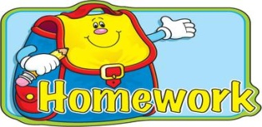
Name: ____________________

Fifth Grade Reading Log

Expectations:
- Reading logs are due every Friday and students will receive their new reading logs on Friday.
- Students should be reading a book at their “Just Right” reading level. (something they can read with good fluency so they can understand what they are reading)
- Students can read anything they like-magazines, graphic novels, newspapers, etc. but should also read good chapter books cover to cover until the book is finished to earn AR points.
- Students may read silently, they may read aloud, or they may read with someone.
- Students need to read at least 25 minutes each night.

Date | Title of Book | Pages Read | Parent Initial
Friday/Saturday/ Sunday

____/____/16
Monday

____/____/16
Tuesday

____/____/16
Wednesday

____/____/16
Thursday

____/____/16

